Registration: Drama in Education Conference
July 23 -24 2016, Reutlingen University
Academic Title
Name
Surname
Institution
Street address
Postal code
City
Email
Conference Fee (includes coffee breaks and lunch on Saturday) |  | 50 € (early bird fee until 15.06.2016)  60€ (after 15.06.2016)
Single Day Fee (Saturday or Sunday) |  | 30 €
Conference Warming (July 22nd) |  | À la carte meal to paid individually – please register so that we can reserve enough space at the restaurant
Conference Dinner (July 23rd) |  | À la carte meal to paid individually – please register so that we can reserve enough space at the restaurant
Fees are due with the conference registration, and must be paid to the following account no later than 4 weeks after registration:
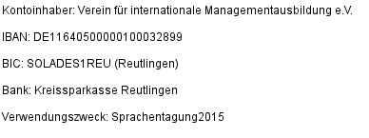

2016

Please save and send the completed application to: stefanie.giebert@reutlingen-university.de

